# **Case Study Data Science in Tourism**

## What is Tourism Business and What are Opportunities

Tourism businesses, such as hotels, tour operators, and travel agencies, may have several **different business objectives**. Some common objectives include

1. Increasing occupancy rates and revenue: This is likely the primary objective for most tourism businesses, as it directly relates to their bottom line.
2. Attracting more tourists: This could be done by advertising and promoting the destination, or by offering competitive prices and packages.
3. Enhancing customer satisfaction: This could include offering excellent service, comfortable accommodation, and a wide range of activities and amenities.
4. Building a strong brand and reputation: A strong brand and good reputation can help a tourism business attract more customers and charge higher prices.
5. Expanding into new markets: This could include targeting new segments of customers, such as business travelers or eco-tourists, or expanding into new geographic markets.
6. Improving sustainability: This could include reducing the environmental impact of the business or promoting sustainable tourism practices.
7. Offering unique experiences: This could include offering unique activities or creating an atmosphere or culture that sets the destination apart from others.

## **What is Data Science in tourism?**

The best way to understand data science in tourism is to understand the concept of data science. It refers to various processes and techniques developed to streamline raw data and use it for effective purposes. Its primary purpose is to help you make sense of data and use it to make informed conclusions and decisions.

Over the years, these processes and techniques have been successfully automated thanks to sophisticated algorithms. The travel sector can now efficiently utilize different types.

Here we can analyze data to see exactly what happened, called descriptive analytics. We can understand why something occurred thanks to diagnostic analytics. Alternatively, we can identify what will happen and what to do next, thanks to predictive and prescriptive analytics.

## **A conceptual business intelligence architecture**

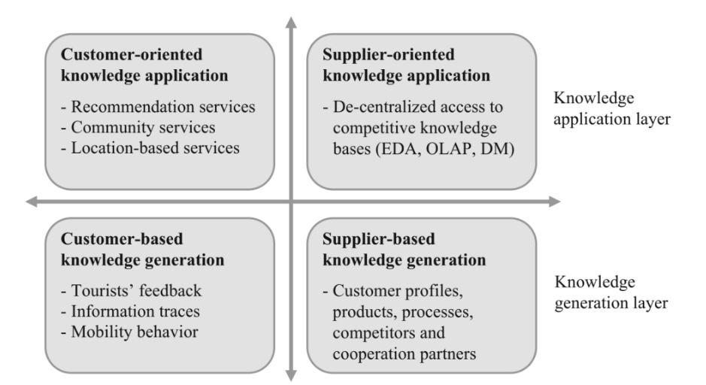

## **Main 4 steps User will go**

1. Dreaming
2. Research & Booking
3. Experiencing
4. Sharing

## **Use cases of AI/ML in the Tourism Industry:**

1. Route Optimization Concept: A customer is always in search of cost-saving and less time travel solutions. Customers always have in their mind that the **traveling time should be minimum** and the time at the desired location should be maximum. Route Optimization can help to fulfill customer needs and to lure them to grab companies’ tour packages. Data Required: Various locations and factors affecting journey time Approach: Graph-based route algorithms  
     
    Impact on Business: User happiness will increase and more likely to bring new customers. So Increasing occupancy rates and revenue Generation.
2. Alerting and Monitoring Systems Concept: find out defects in systems and overcome them. In the touring business many factors such as climate, vehicle failure, staying issues, health-related issues, etc. This alerting and monitoring system helps passengers as well as tourism companies to overcome the problems in the Travel Industry. **Qantas Airlines** significantly reduced the number and length of delays. Data Required: Various factors affecting the journey Approach: IoT & AI-based applications  
     
    Impact on Business: User retention, Revenue Retention, Building a strong brand and reputation
3. Sentiment Analysis Concept: We can use people’s social media past and existing trends to offer them different tour packages as well as to serve them better.  
   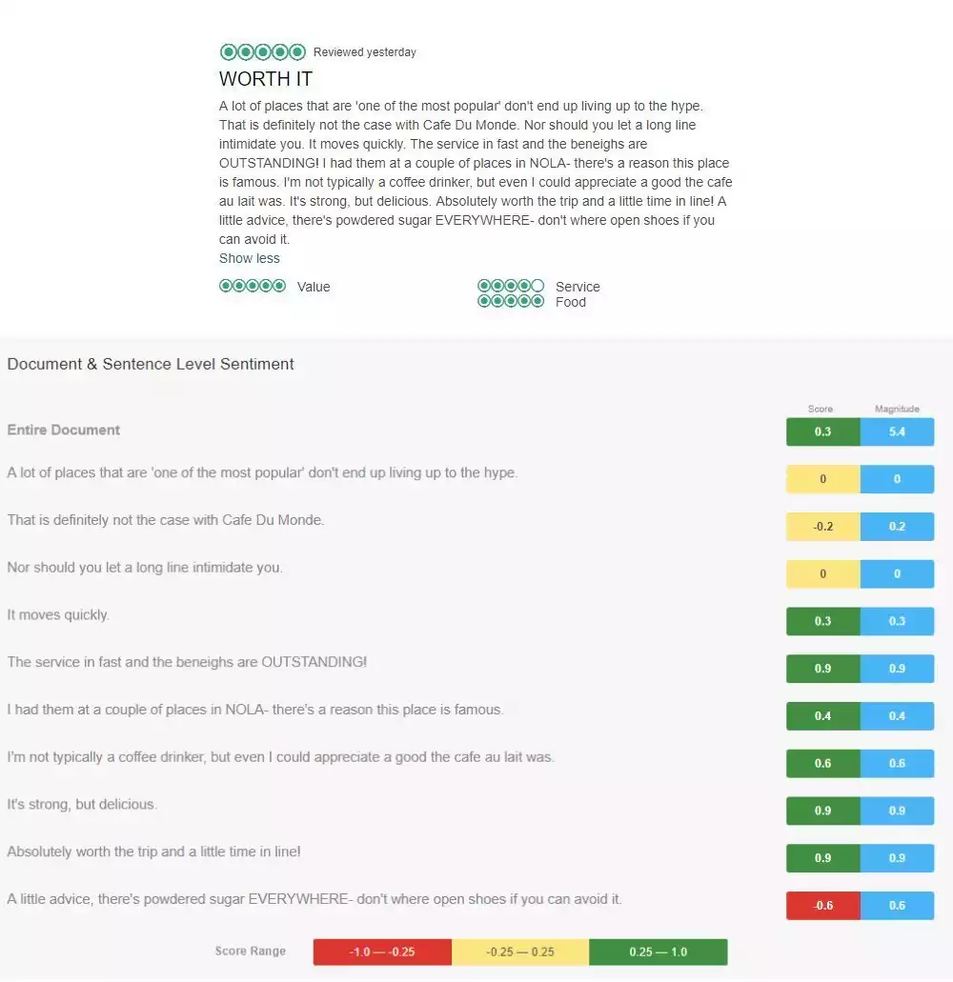  
     
   Sentiment analysis of a Cafe Du Monde  
     
    Data Required: Customer Reviews Approach: data web scraping among social media & website platforms  
     
    Effect on Business: Give a competitive edge to business, revenue generation
4. Predictive Analysis Concept: use past experience to predict which places will draw more customers Data Required: Booking Data, User reviews Approach: general MLOps approach  
     
    Impact on business: demand forecasting, easier resource management & effective use of revenue
5. Personalization / Recommendation System Concept: Show more related places and packages to afford like with family, couple, etc on specific websites or applications. **Expedia-hotels, Booking. com-destination,** [**Fareboom.com**](http://fareboom.com) **travel agency suggesting alternative dates for a trip**. Data Required: Booking Data Approach: Neural Networks  
     
    Impact on Business: Find out what customers want, Enhance customer satisfaction, decreasing customer churn.
6. Intelligent Travel Assistants with Customer Support Concept: AI algorithms, conditioned to carry out a certain job on a user’s demand, are often called **“Chatbot” or “bots”**. Several prominent companies extensively use instant messaging applications. This is an excellent strategy to get in touch with customers and develop improved customer relationships with analysis using data science in the travel industry. **Hyatt**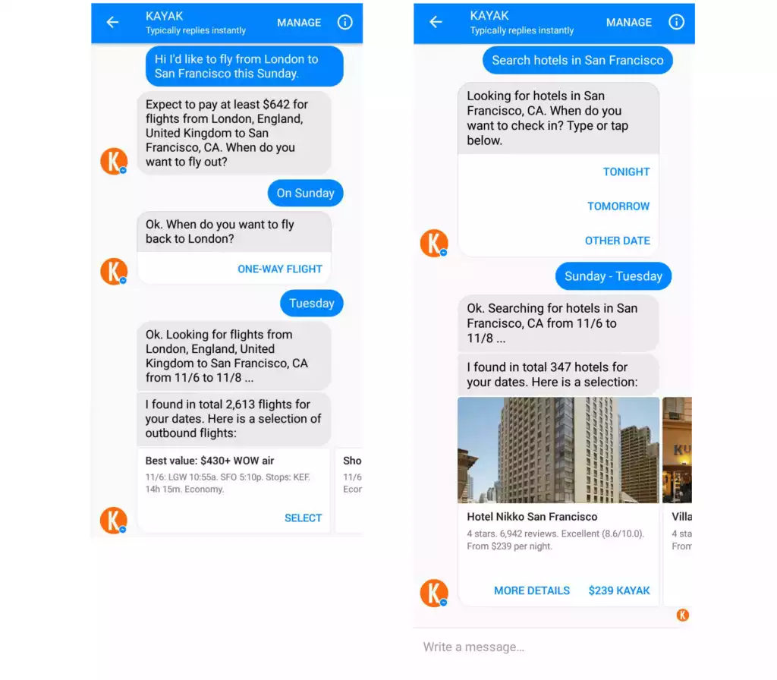  
     
    Kayak travel assistant  
   * Customer support will allow us to find customer lost assets with help of an advanced bot.

Data Required: Booking Data Approach: Rasa and PyTorch, dialogue flow platforms  
Impact on Business: prevents customers from waiting to receive responses, customer retention, revenue retention

1. Travel Fraud Detection Concept: Airlines in addition to travel industries confront e-commerce fraud probably the most. They shed billions of bucks each year by being forced to **refund money** that is stolen from customers. Transaction fraud is probably the most **widely used kind of scam**. This specific sector involves using a stolen credit card for booking accommodation or flights. User behavior assessment, user profiling, machine learning solutions, and data science in the travel industry can assist in avoiding and **identifying fraudulent transactions** from transpiring. AI remedies for fraud detection are suitable for web-based platforms and also smartphone booking apps likewise look for personalized models to forecast and identify fraud that authorized them to minimize chargebacks to fifty percent.  
     
    Data Required: Booking Data Approach: proper data modeling and MLOps  
     
    Impact on Business: Revenue optimization or Improving sustainability
2. Tailored offers for MVCs (most valuable customers)  
     
    Concept: Tailored offers for new and unregistered users employing and most valuable users that the travel industry plans to focus on first to avoid churn. We can say **customer churn prediction**.  
     
    Data Required: Booking Data, User reviews  
     
    Approach data analysis  
     
    Impact on Business: Revenue Churn Reduction or Increasing occupancy rates and revenue generation
3. Descriptive Analysis  
     
    Concept: General Data from Past Approaches  
   * Better understand customers
   * Dynamic pricing management
   * Improve brand image
4. Use past experience to predict which places will draw more customers & which customers will revisit places, agencies, etc. **Venice and Salzburg** as perfect examples of smart tourism destinations  
     
    Data Required: Booking Data, User reviews  
     
    Approach basic MLops  
     
    Impact on Business: Better User Understanding, Effective Revenue generation process
5. Biometric boarding  
     
    Concept: customer verification purpose in fingerprint or Facial Recognition.  
     
    Data Required: User data  
     
    Approach: Image Recognition  
     
    Impact on Business: User Comfortable, stronger brand reputation, revenue generation
6. Multilingual real-time translation Concept: There are several companies such as Pilot and Google Pixel buds that offer a real-time translation service, based on Artificial Neural Networks and Deep Learning. This is a boon for corporate business travelers. These apps operate through an earpiece and offer translation into multiple languages.

Approach: NLP & clustering

Impact on business: Revenue Retention

1. Employee performance management using AI/ Human Resource Management

Impact on business: Revenue Optimization

1. Automated Equipment in vehicles for customers

Impact on business: Revenue Optimization, Offering unique experiences

1. Fuel Consumption Optimization

Impact on business performance: Revenue optimization

1. New or Refining Tourism Place search using search patterns vs booking and Hike recognition

Impact on business: Revenue Generation, Offering unique experiences, Attracting more tourists, Expanding into new markets

1. Ad targeting: AI can analyze data to identify the most effective target audience for an ad campaign and optimize it for better performance.

Business impact: increase efficiency and reduce costs, and make more informed decisions about their marketing strategies.

## **Why is Data Science important for the tourism industry?**

The role of data Science in the tourism and hospitality industry is becoming increasingly important with every passing few years. Thanks to new IT technologies, companies in the travel sector can now efficiently track, record, store, and process big data, which enables even small companies to benefit from cutting-edge solutions.

Advances in cloud technologies and infrastructure that support big data and data analytics enabled service providers to decrease costs. It simply means that the travel sector can now use big data in a cost-efficient manner.

Data science unlocks many opportunities for travel companies. First and foremost, it allows people who are not data science experts to quickly review large-scale volumes of data. That is important because most of the touch points consumers have with travel businesses are now online, and each one produces some data.

Data science can finally equip travel companies with everything they need to understand their target customers and capture more profit – or, in other words, gain a competitive advantage.

At the same time, your business also generates internal data. Data Science is essential because you can truly understand your business processes and how your company interacts with partners and customers.

Final Impact on Business overall based on past experience over other companies:

* Increasing productivity (40%)
* Reducing operating costs (28%)
* Improving speed to market (21%)
* Transforming the business and operating model (20%)
* Improving bottom-line growth (19%)
* Improving customer engagement (18%)

Various Techniques going to be used in these:

web scraping, feature engineering, clustering, dimensionality reduction, classification, Regression, hyperparameter tuning, model evaluation, interpretation of models, text representations and word embeddings, Sentiment analysis, Topic modeling, entity matching, knowledge graphs, network analysis, Time series analysis, Agent-Based Modeling, GIS Analysis, and Visual data analysis

## **Major types of data going to be in Tourism**

### **UGC data (generated by users)**

This abbreviation stands for User Generated Data. This is the cheapest data to obtain and includes textual data obtained from questionnaires and social networks, as well as photo data.

### **Device data (by devices)**

This data is quite expensive to obtain (its cost depends on the territories covered and the period allocated for the study). It includes GPS data, mobile roaming data, Bluetooth data, etc. Generally, these data will be of company vehicles.

### **Transaction data (by operations)**

This source includes web search data, web page visit data, online booking data, etc. Typically, advanced web services such as Google Analytics are used to obtain this data.

## **Data Sources:**

* Social Media
* Websites collecting data for travel
* Data sets available on popular platforms like Kaggle, and Airbnb
* Manual Collection in the Client environment
* various benchmarking datasets

[AI and Data Science in Aviation Industry: 5 Real-life Use Cases](https://www.youtube.com/watch?v=D8NlYPtPgwA&ab_channel=AltexSoft)

[Impact of Data Science on Tourism Industry | How Data Science is Used in the Travel Industry](https://youtu.be/a1FB3KUWp08)

[Machine Learning and Artificial Intelligence in Travel](https://www.youtube.com/watch?v=xjLNBwZHUtA&ab_channel=HSMAI)

[SMART TOURISM : Big data, artificial intelligence and robotics revolutions](https://youtu.be/d9nP05RTu4Q)

[Solutions for the travel and hospitality industries - Azure Architecture Center | Microsoft Learn](https://learn.microsoft.com/en-us/azure/architecture/industries/travel-hospitality)

----------------------------------------------------------------------------------------------------------------------

Not for client Use

Tourism business transactions and generated data

|  |  |
| --- | --- |
| Business transaction | Generated data |
| Offer (generation)  Generation of adaptive and personalized  offers of tourism products and services | * Offer description in supplier IT systems (e.g., ERP system, CRS/PMS) * online supplier listings (e.g., yellow pages or registries like UDDI) * Official product/offer statistics |
| Marketing  Offline marketing via traditional media as  well as online marketing activities via  websites, display advertising, search engine marketing (SEM), content marketing (e.g., UGC marketing), social media marketing (SMM), or email marketing | Website content   * Advertising/placement statistics in marketing networks, search engines, social media posts, comments in social media (email) Marketing messages * Offline marketing statistics |
| Information (consumption) and search  Information search via search engines, travel  websites (from DMOs, suppliers,  intermediaries, etc.), mobile apps/guides  (e.g., Google Maps, mobile city guides, etc.),  social media sites (e.g., TripAdvisor,  YouTube, Facebook, Twitter, etc.), as well as  information requests via email, messaging  services (e.g., WhatsApp), or social networks  (e.g., Facebook, Twitter, etc.) | * Search engine traffic and search terms (e.g., Google Trends) * Web navigation behavior/traffic (page views and search terms) (geo-referenced) * Mobile interactions Social media traffic (e.g., downloads, impressions, followers, likes, etc.) * Social media interactions: posts, comments, etc. Information request/message |
| Reservation and booking  Reservation or booking of tourism services  via CRS/GDS, PMS, or any other kind of  booking systems, online platform and  Internet booking engine, or social media  platform (e.g., Facebook) | * Booking records including customer information (e.g., PNRs) * Web navigation behavior/traffic * Social media navigation behavior * Official statistics with booking information |
| Consumption  Arrival or stay at a destination or  consumption of accommodation product,  transportation services, or local tourism  products like attractions, activities, events,  food and beverage, etc. | * Arrival/overnight figures via accommodation providers’ CRS/PMS, official statistics, mobile apps/guides usage, or consumption of other local tourism products (e.g., paid by credit card, etc.) * Overnight figures via accommodation providers’ CRS/PMS or official statistics * Transportation figures by suppliers’ CRS/GDS, ticket system, etc. or official statistics (by IATA,etc.), including traffic, delays, no-shows, etc. * Consumption figures via ticket offices/sales, supplier systems (e.g., cash systems), credit card payment or online/mobile payment, (mobile)   customer cards or loyalty programs, location tracking (by mobile phones, GPS tracking, beacons, etc.), sensors and cameras, or official statistics |
| Information provision and feedback  Provision of travel information and feedback  via online review sites (e.g., TripAdvisor),  supplier-specific online feedback or survey  systems, or social media platforms (e.g.,  Facebook, Flickr, Google Maps, etc.) | Product reviews from online platforms, typically including basic demographic customer information   * Posts, comments, photo uploads, * check-in/check-out, etc., typically including basic * demographic customer information and often geo-referenced |

